W1500A-How to setup the Universal Repeater Mode
Product line: wireless question category: Internet setup
Connect your computer to the LAN port of W1500A, power on W1500A, as the following picture.
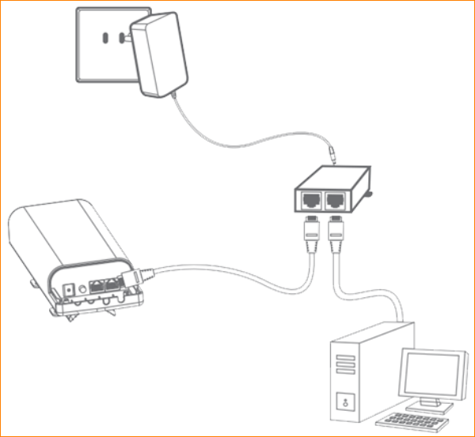
Attention: After connection, the Power light should be blinking, LAN light should be on, WLAN light should be on or blinking
Set a static IP for your computer
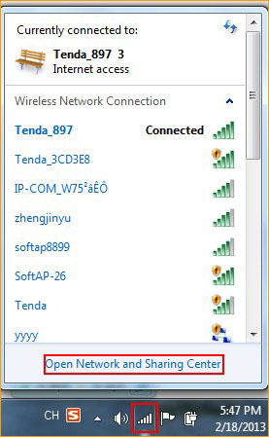
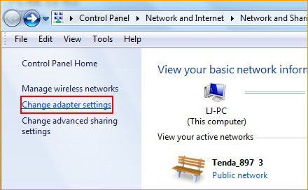
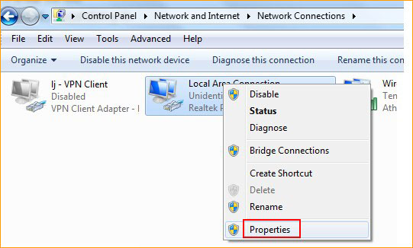
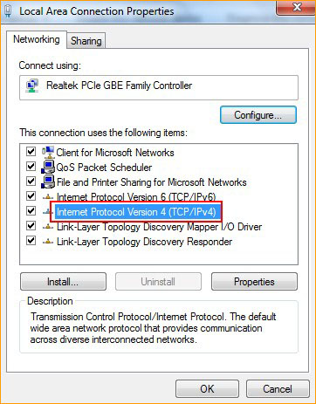
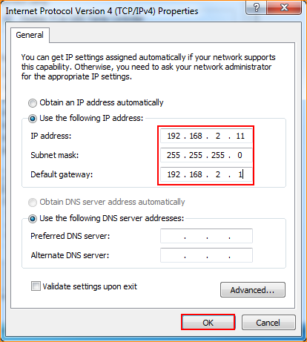

Open a browser or safari, then input 192.168.2.1 in the address bar, click Enter to login to the management page of W1500A.
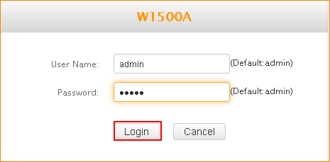

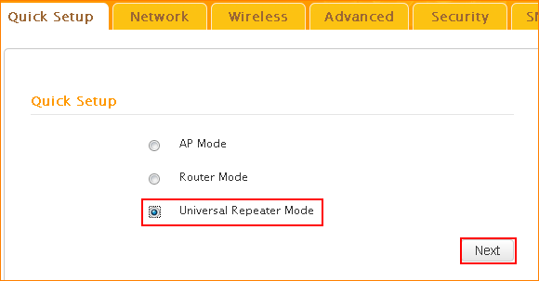
Scan and choose your uplink device’s SSID, and then fill in the information of your uplink device.
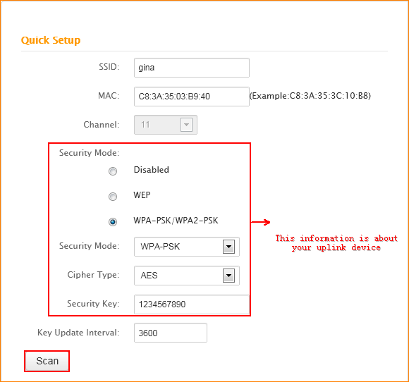
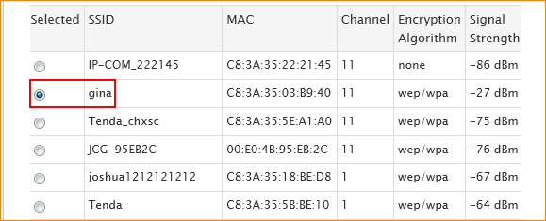
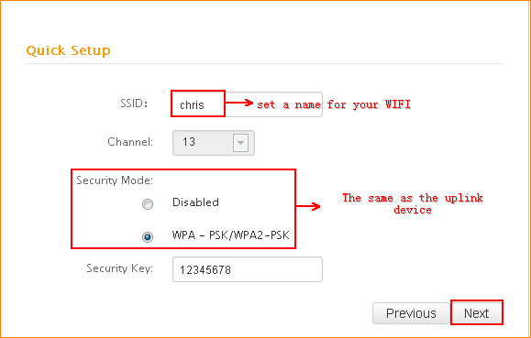
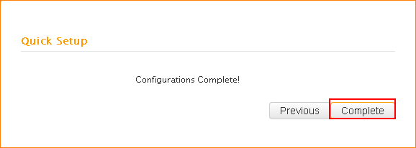
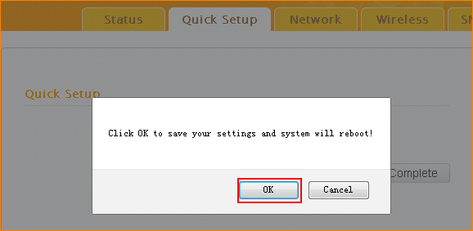
After reboot, the universal repeater mode has been setup, please reconfigure your computer to obtain the IP address automatically.
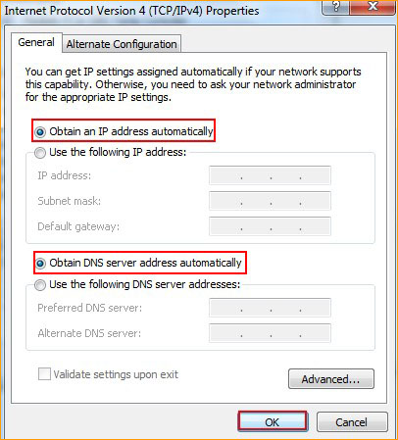
If your computer can get the IP assigned by your uplink device, it means that W1500A has been setup successfully, you can enjoy internet from it now.

